Product page plan

Article: [Creating Your Product Page](https://developer.apple.com/app-store/product-page/) by Apple Developer

# Requirements

## App name

## Icon

* Future opportunities to optimize this
* Let people know whats going on in the world (iterations for elections, etc)

## Subtitle

-A set of words that is short, gets good results on the app store, and hasn’t existed before

What your app does and who it’s for

## App previews

* See video
  + <https://drive.google.com/file/d/13hDq0P8HDZvEMZMOKfphCOy4oW4gNszc/view?usp=sharing>
  + <https://apps.apple.com/us/app/audible-audiobooks-podcasts/id379693831>
  + https://drive.google.com/file/d/1fBOJ8_GVac5-rQhL9WH_7-bTACJO2-jJ/view?usp=sharing

### Notes

* <https://developer.apple.com/app-store/app-previews/>
* Autoplay upon user landing
* Capture app footage from the device using QuickTime Player on macOS simply by connecting your device to a Mac. You can also use iMovie or Final Cut Pro X to edit your previews.
  + Add graphic elements, such as touch hotspots, when necessary to demonstrate how navigation or interaction works within the app. Don’t overlay animated hands simulating gestures.
  + Since app previews play with the sound muted by default on the App Store, consider using copy to give context to the footage. Use easily understandable terms and language that will appeal to your target audience.
* up to 30 seconds long
* Think about using your first app preview to show an overview of the app experience, focusing on the app’s core features and content. Aim to tell a cohesive story that gives users a sense of the journey they’ll experience when using your app.
* Develop an outline or storyboard for each video that maps out a list of scenes you’ll need, and consider how many seconds you want to devote to each scene. Craft messaging to explain UI transitions or features.
* -Select a poster frame
  + Poster frames appear wherever app previews do not autoplay, so it’s important to select a visually compelling frame from your footage.

### Ideas:

* 1-3 videos and test which works best
* 1 video, a swipable user journey with copy & voice over (could we get a radio host to do this?)

## Screenshots

* Use images captured from your app’s UI to visually communicate your app’s user experience.
* You can feature up to **10 screenshots** on your App Store and Mac App Store product pages.
  + 10 per device
  + Ipad, phone etc
* Depending on the orientation of your screenshots, the first one to three images will appear in search results when no app preview is available
* 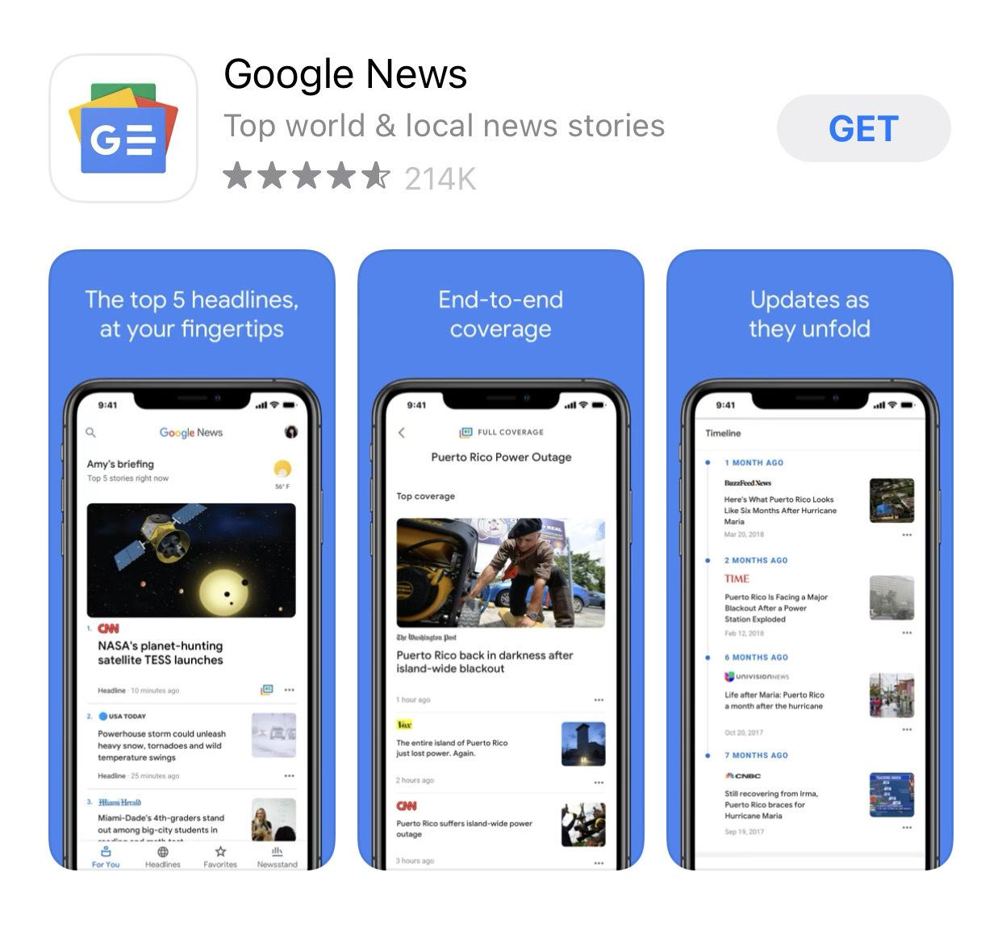
* Make sure these highlight the essence of your app. Focus each subsequent screenshot on a main benefit or feature so that you fully convey your app’s value.
* For screenshot specifications, see [App Store Connect Help](https://help.apple.com/app-store-connect/#/devd274dd925).

## What’s New

### Notes

When you update your app, you can use What’s New to communicate changes to users. This text appears on your product page and on the Updates tab.

If you added a feature or fixed a bug based on feedback, use What’s New to let users know that you’ve listened to them. List new features, content, or functionality in order of importance, and add call-to-action messaging that gets users excited about the update.

### Ideas

* Consider using bullet points, like in this example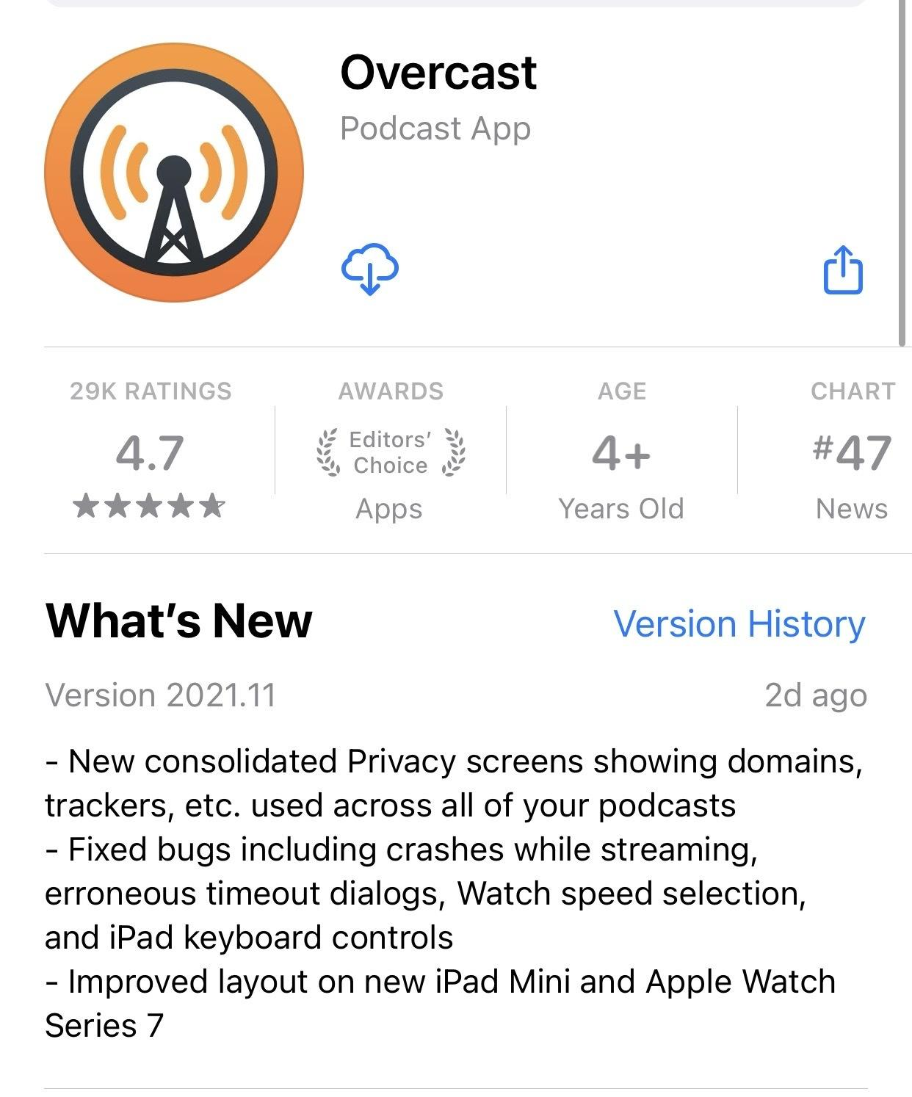

## In-app Events

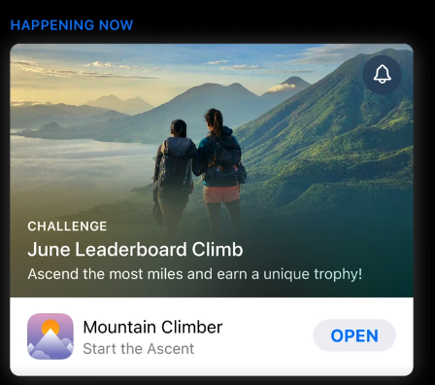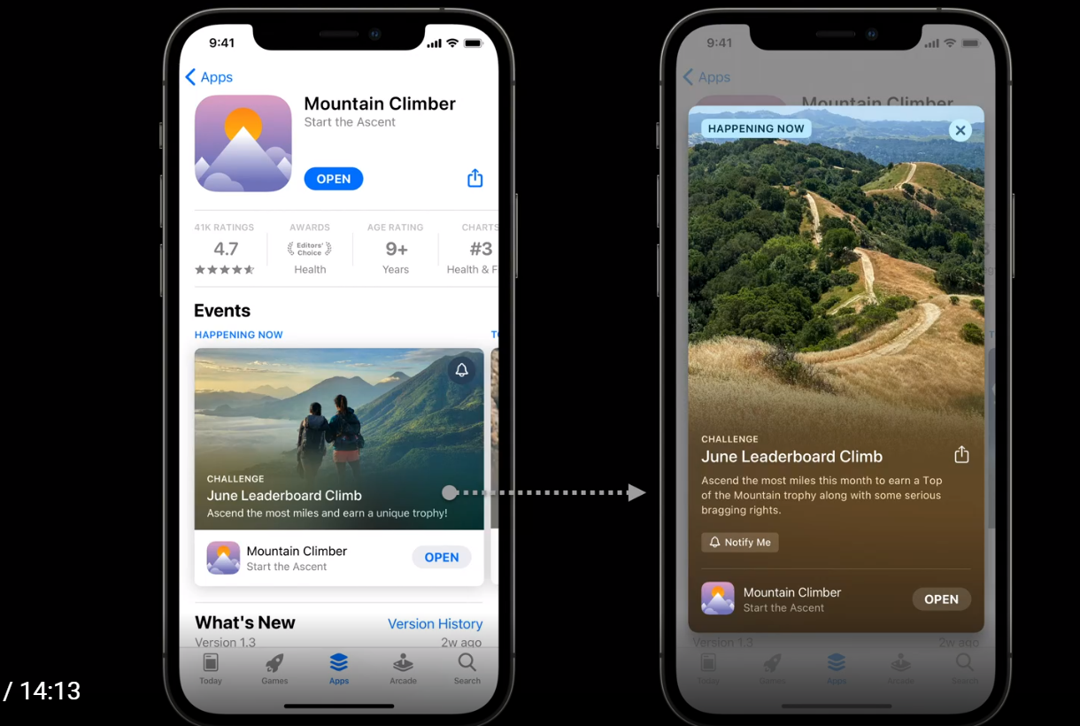

-New motive season tonight

- promote up to 2 weeks before they start

- Pledge drive

## Description

## Promotional text

Your app’s promotional text appears at the top of the description and is up to 170 characters long. You can update the promotional text at any time without having to submit a new version of your app. Consider using this to share the latest news about your apps, such as limited-time sales or upcoming features.

## Keywords

## ~~In-app purchases~~

## Ratings and reviews

## Categories

## Localization

If your app is available in multiple languages, make sure to localize your app description, keywords, app previews, and screenshots, for each of the markets in which you offer your app. You can also translate your app’s name and tailor your keywords to reflect the values of each market so your app might better resonate with the local audience.

For details, see [Localize App Store information](https://help.apple.com/app-store-connect/#/deve6f78a8e2).

To learn about localizing your app, expanding [Your App to New Markets](https://developer.apple.com/localization/).

## Get more from your product page

Coming Soon: Product page optimization.

* Optimize your product page by comparing different app icons, screenshots, and app previews to see which resonate most with customers.
  + View results in App Analytics in App Store Connect and makes the top-performing assets the one all customers will see.

* Custom product pages.
  + Create additional versions of your product page with different promotional text, screenshots, and app previews to better showcase particular features or content within your app.
  + Direct relevant audiences to a particular page using its unique URL and view performance in App Analytics.

[Learn more.](https://developer.apple.com/app-store/product-page-updates/)

Default Page